**ShigaTyper**

ShigaTyper is a quick and easy tool designed to determine *Shigella* serotype using Illumina paired end reads with low computation requirement. It has been tested on an Ubuntu 16.04.3 LTS guest addition on VMware Player version 14.1.1 in a Windows 7 and Virtual Box version 5.2.4 in a Windows 10 operating system. If you are not familiar with Linus system or WGS analysis, please refer to the ShigaTyper user tutorial, where instructions are included for system setup and how to run the analysis.

**Dependencies**

All can be installed via Anaconda

1. Jupyter Notebook (install from Anaconda with Python 3.6 or later)
2. fastp version 0.12.2 or later
3. minimap2 version 2.9 or later
4. samtools version 1.7 or later
5. bcftools version 1.7 or later
6. papermill version 0.12.5 or later

Note: fastp requires Python 2. If you have Ubuntu 18.04 LTS, you might want to either install Python 2 for fastp to work, or disable fastp by editing RunNotebooks_100518.ipynb (in cell 1, change fastp = 0 to fastp = 1).

**Run ShigaTyper**

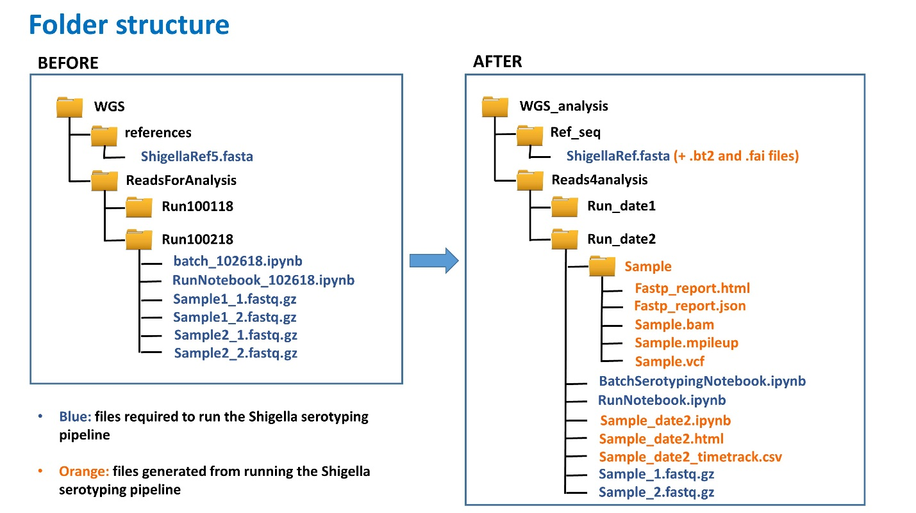Download the following 3 files and place them following the file organization shown in the figure below:

1. batch_102618.ipynb
2. RunNotebooks_102618.ipynb
3. ShigellaRef5.fasta

Note: if you change the reference file path or name you will have to edit the directory to reference in “batch_102618.ipynb” for ShigaTyper to run (currently it is set at “../../references/ShigellaRef5.fasta” in the 6th cell):

[optional] if you want to omit QC inspection, in the first cell of RunNotebooks_102618.ipynb, change from “fastp = 0” to “fastp = 1”.

1. Open Terminal and switch directory to the folder containing WGS reads, or its parent folder.
2. Type “jupyter notebook” to turn on Jupyter Notebook in the default browser (Firebox in Ubuntu).
3. Navigate to the folder containing the jupyter notebooks and fastq.gz files to be analyzed.
4. Click on “RunNotebooks_102618.ipynb” to open it in a new tab.
5. Click on “Cell” then “Run All” to start the analysis as shown in the following figure: 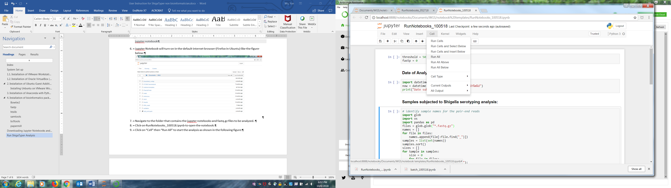
   1. The notebook will automatically run to finish. Samples analyzed before in this notebook will be erased and replaced by results from the new samples. You can see the progress for each of the sample:

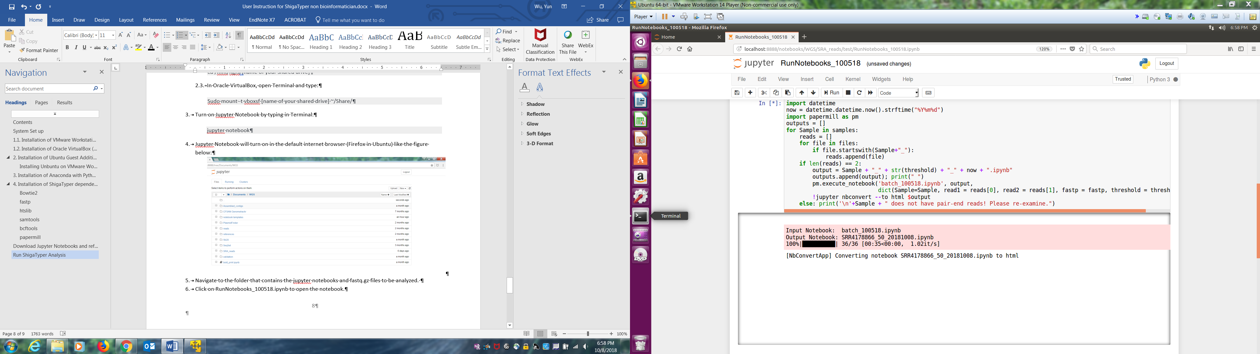

* 1. A html report is automatically generated for each of the sample.
  2. When the analysis of all samples is complete, a summary table is generated at the end of RunNotebook_102618.ipynb as below:

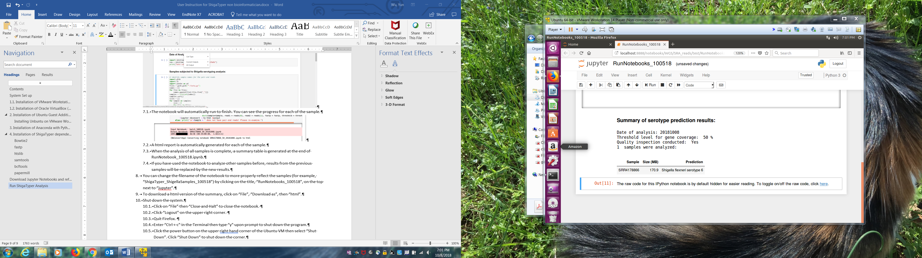

1. Click “File” then “Save” to save the results. You can change the filename of the notebook (for example, “ShigaTyper_ShigellaSamples_110518”) by clicking on the title, “RunNotebooks_102618”, on the top next to “jupyter”.
2. To download a html version of the summary, click on “File”, “Download as”, then “html”.
3. Close Jupyter Notebook.
   1. Click on “File” then “Close and Halt” to close the notebook.
   2. Click “Logout” on the upper right corner in the main page. Quit browser.
   3. Enter “Ctrl + c” in Terminal then type “y” upon prompt to quit Jupyter Notebook.